CSA1708-ARTIFICIAL INTELLIGENCE
LAB EXPERIMENTS
Program 21 : Prolog Program to Implement Towers of Hanoi
Aim
To use recursion in Prolog to list the legal moves for a positive number of disks in the Towers of Hanoi puzzle.
Algorithm
1. If one disk remains, move it directly from the source peg to the destination peg.
2. Move the top N - 1 disks from the source peg to the auxiliary peg, using the destination as the spare peg.
3. Move the largest disk from the source peg to the destination peg.
4. Move the N - 1 disks from the auxiliary peg to the destination peg.
Program
hanoi(1, From, To, _) :-
format('Move disk from ~w to ~w~n',
[From, To]).
hanoi(N, From, To, Aux) :-
N > 1,
Next is N - 1,
hanoi(Next, From, Aux, To),
format('Move disk from ~w to ~w~n',
[From, To]),
hanoi(Next, Aux, To, From).
Sample Input
?- hanoi(3, left, right, middle).
Program Execution
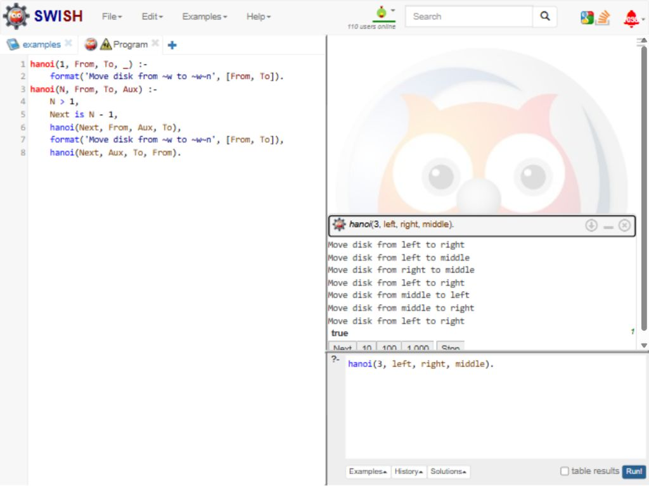
RESULT
Thus, the recursive Prolog program displayed the seven legal moves needed to transfer three disks from the left peg to the right peg.

